Annals of the University of Craiova
The Chemistry Series
Volume XLVII, No. 2 (2021) xx-yy
homepage: chimie.ucv.ro/anale/

Title article

Research article

Prenume Nume¹*, Prenume Nume², …

¹University of Craiova, Faculty of Sciences, Department of Chemistry, Calea București 107i, Craiova, Romania
²University, Faculty, Department, Name of Organization, Full address
*E-mail: user@yahoo.com

Received: dd.mm.yyyy / Accepted: dd.mm.yyyy / Published: dd.mm.yyyy

Abstract
The abstract should be an objective representation of the article, it must not contain results that are not presented and substantiated in the main text and should not exaggerate the main conclusions.

Keywords: keyword 1, keyword 2, keyword 3, keyword 4, …

1. INTRODUCTION

Heavy metal contamination due to anthropogenic causes is a challenge for the ecosystems, where plants are at the first level of the trophic pyramid. Phytohormones are signal molecules that integrate the plants’ developmental program with their environmental conditions, acting both near their synthesis site and at distance [1]. It’s therefore important understanding the role of phytohormones in plants responses to heavy metals stress [2-4].
The purpose of the study, whose results are presented below, was to investigate certain physiological and biochemical responses of wheat plants grown in laboratory conditions on solidified nutrient solutions containing excess Cu²⁺ (as CuCl₂), in the absence or presence of GA₃ supply. We aimed to find out if any of the analyzed parameters of wheat plants grown at toxic concentrations of Cu²⁺ were relevant for the effects of GA₃ supply in wheat plants exposed to coppers stress.

2. MATERIALS AND METHODS

2.1. Materials

The stock solution of gibberellic acid was prepared using the commercial product GibbA3, recommended as growth regulator (stimulator), conditioned as soluble tablets containing 20 % GA₃ of fungal origin, and effervescent co-excipients up to 100 %. The other solutions used in the experiments were prepared with analytical grade reagents from Sigma and Merck. Wheat caryopses (Triticum aestivum L.) were obtained from the Agricultural and Forestry Technologies Department, Faculty of Agronomy of the University of Craiova.

2.2. Analysis methods

Surface sterilized wheat caryopses were placed in Petri dishes for germination, on filter paper wetted with distilled water, for 24 hours in the dark. Uniformly germinated caryopses were transplanted into Petri dishes of 90 mm diameter containing 50 mL of nutrient solution [9], solidified with 0.5 % agar. Some of the nutrient solutions were supplemented with the appropriate volumes of the stock solutions of 1 mmol·L⁻¹ GA₃ and/or 10 mmol·L⁻¹ CuCl₂, in order to obtain the final concentrations of the test solutions indicated in table 1. Growth media without GA₃ and excess Cu²⁺ were considered as control. The significance of the experimental variants (which can be formally divided into two series: without excess Cu²⁺ and with 100 μmol·L⁻¹ excess Cu²⁺) is presented in Table 1.
Table 1. Table type styles (Table caption is indispensable).
No. | Experimental variant | Concentration within the growth media
No. | Experimental variant | GA₃/μmol·L⁻¹ | Excess Cu²⁺/μmol·L⁻¹
1 | CONTROL | - | -
2 | GA₃ 10 μmol L⁻¹ | 10 | -
3 | GA₃ 20 μmol·L⁻¹ | 20 | -
4 | Cu²⁺ 100 μmol·L⁻¹ | - | 100
5 | Cu²⁺ 100 μmol·L⁻¹ + GA₃ 10 μmol·L⁻¹ | 10 | 100
6 | Cu²⁺ 100 μmol·L⁻¹ + GA₃ 20 μmol·L⁻¹ | 20 | 100

The Petri dishes were placed in laboratory condition, at 16/8 hours photoperiod and temperature of 25/20 °C.

2.3. Title section

The formula, the equations and the chemical reactions will be numbered with Arabic digits, in small parenthesis as in (1), in their chronological order, inserting into the right place in the paper:

$\text{μ=}\frac{\sum_{\text{i=}1}^{N}{x_{i}}}{N}$ (1)

$\text{σ=}\sqrt{\frac{\sum_{\text{i=}1}^{N}{{\left(x_{i}−μ\right)}^{2}}}{N−1}}$ (2)

where N is the size of the assayed sample (i.e. the number of plants), x represents the values of the measured parameters (root and stem length, respectively), μ is the mean (average of the observed values), and σ is the standard deviation, a measure of dispersion from the mean of the observed values.
2.4. Title section

The spectrophotometric measurements were performed with a Varian Cary 50 UV-Vis spectrophotometer. Values of the assayed biochemical indexes, expressed in appropriate units, were reported per fresh weight (i.e., g⁻¹ FW) for glucose, protein and pigment concentrations, while the enzyme activities were expressed as U·g⁻¹ protein. Data are averages of three measurements±standard deviations.

3. RESULTS AND DISCUSSION

3.1. Title section

In wheat plants grown on media without GA₃ and Cu²⁺ excess (control) the root and stem length values were 112±17.51 mm and 144±19.55 mm, respectively (Figure 2). In the absence of Cu stress, exposure to GA₃ resulted in moderate to low increased length of plant roots (14 %) and stems (7 %) compared to unexposed controls, irrespective the concentration of the hormone.

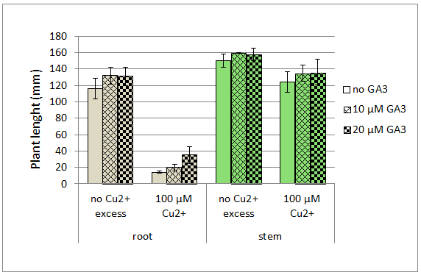 | 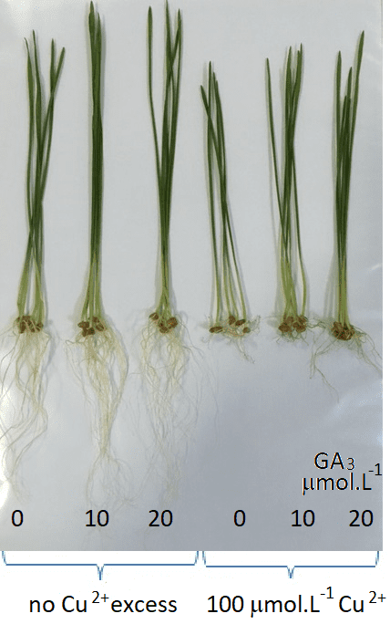
Figure 2. left -Root and stem length of the wheat plants grown on media with 10 μmol·L⁻¹ and 20 μmol·L⁻¹ gibberellic acid (GA₃), in the absence or the presence of excess Cu²⁺; right-a photo of the experimental samples

3.2. Title section

In all the plants exposed to excess Cu²⁺, CAT activity was lower than in the unexposed ones (by about 30 %). Within this group, CAT increased with 13 % at 10 μmol·L⁻¹ GA₃ relative to the corresponding sample without the added hormone, and only a 3 % increase was noticed at 20 μmol·L⁻¹ GA₃. The low or no effect of GA₃, on catalase activity was quite similar for the two experimental series.

4. CONCLUSION

Copper is an essential microelement, but toxic when exceeded a certain threshold. It has many ways to express its toxicity: directly, by substituting essential metals in biomolecules or by generating reactive oxygen species, and indirectly, intervening in signaling networks. As a phytohormone, GA₃ contributes to the best fit of the plant with its environment; in plants with sufficient endogenous GAs, exogenous GA₃ might become toxic.

REFERENCES

- J. M. Rippe and T. J. Angelopoulos, Nutrients, 8 (2016) 697.
- E. H. Colebrook, S. G. Thomas, A. L. Phillips and P. Hedden, J. Exp. Biol., 217 (2014) 67.
- L. Bücker-Neto, A. L. S. Paiva, R. D. Machado, R. A. Arenhart and M. Margis-Pinheiro, Genet. Mol. Biol., 40 (2017) 373.
- A.Shukla, S. Srivastava, P. Suprasanna, Curr. Genomics, 18 (2017) 512.
- O. Sytar, P. Kumari, S. Yadav, S.M. Brstic, A. Rastogi, J. Plant Growth Regul., 38 (2019) 739.
- https://en.wikipedia.org/wiki/Plant_hormone
- T. Asami and Y. Nakagawa, J. Pestic. Sci,. 43 (2018) 154.
- P. Heden and S. G. Thomas, Biochem. J., 444 (2012) 11.
- J. Binenbaum, R. Weinstain and E. Shani, Trends Plant. Sci., 23 (2018) 410.
- V. Page and U. Feller, Ann. Bot-London, 96 (2005) 425.

